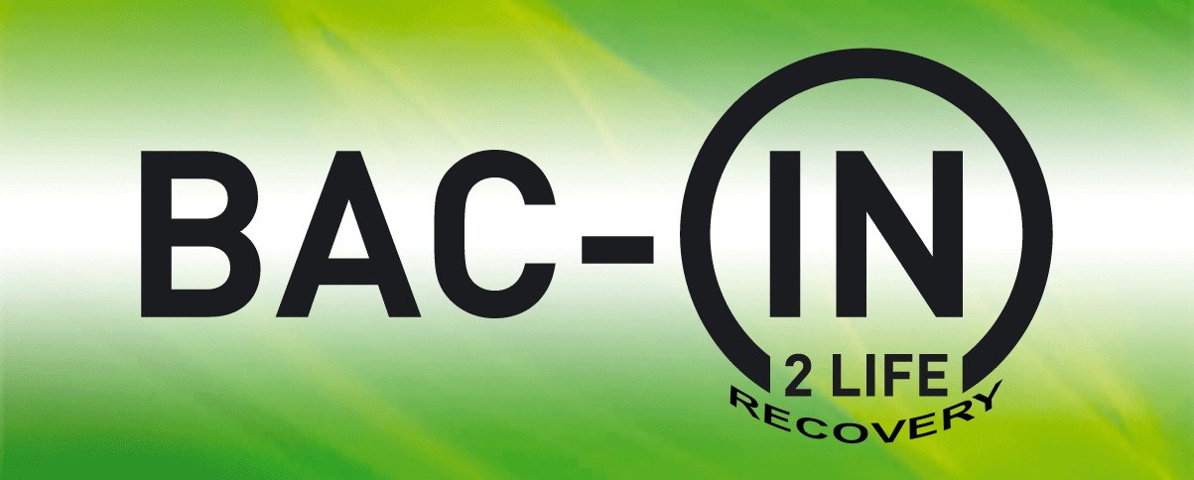
Job Description/Person Specification
Post title:  Community Engagement Worker  (Project Make it Happen – National Lottery funded post) | Location of service area/s:  Nottingham, Derby &Leicester

Hours of work: 37.5 hours | Salary: £27,500 (starting salary depending upon experience)
Responsible to: Service Manager | Accountable to: BAC-IN Directors Board

Service Description/Outline of the post:
BAC-IN is a grassroots, peer-led service, founded in 2003 by a group of local BAME community leaders with 'lived experience' of addiction recovery and rehabilitation. We provide a holistic and culturally tailored approach to addiction recovery, mental health and multiple disadvantage to help individuals, families and young adults from Black, Asian and Minority Ethnic communities to realise the best of their life potential. We support people to achieve sustainable recovery, make responsible lifestyle choices and changes and build positive relationships. BAC-IN is a culturally specific Service and this means that we are exempted under Section 5 (2) (d) of the Race Relation Act 1976. Project ‘Make It Happen’ will focus on more intensive face to face one to one and group support, working with people in the greatest need including those who have been particularly affected by the impact of the pandemic on their mental health and wellbeing and those who have returned to or increased their substance misuse to help them cope. The project will provide a range of expert and peer-led support services to BAME individuals and families. BAC-IN Community Engagement Worker will work with BAME individuals and families experiencing mental health, substance misuse issues and related multiple disadvantage delivering 1:1 sessions, Group Support and Community Outreach. The role will include conducting comprehensive needs assessments with women and families referred to the service, implement care plans following needs assessment, help women move from dependence to interdependence and help engage people from existing and new communities in treatment and recovery.
Main Responsibilities and Activities
- Possess the ability to embrace, empathize and work with clients from BAME disadvantaged backgrounds.
- Increase outreach activities to reach the most vulnerable and marginalised.
- Provide community-based, accessible and culturally appropriate support.
- Help and support women and families in BAME communities to tackle substance misuse and multiple disadvantage.
- Provide outreach support as well as refer families / children to other services and help them access other forms of support for holistic family development.
- Manage a caseload and to develop and implement planned interventions with women and families.
- Help vulnerable children and their families’ access additional services as appropriate, whether mainstream or specialist.
- Capacity to empower the quality of life of people who face severe and multiple disadvantage (disadvantage clusters, particularly homelessness, substance misuse, mental health issues, violence, abuse, unemployment and poverty).
- To deliver mental health and recovery based support activities for BAME people in Nottingham and designated locations
- To hold a delegated case load under the supervision of the Service Manager.
- To undertake home visits with new and existing clients
- To identify new clients who use drugs and alcohol and provide a responsive accessible service, through various modalities including assertive outreach.
- To undertake appropriate personal and professional development opportunities.
- Appropriate case management and referral / liaison with other service providers.
- To maintain comprehensive case notes and records of all work undertaken, including statistical data for collection of reports.
- Delivery of group work interventions including personal development, Mental Health and Multiple Disadvantage awareness workshops.
- Maintain effective working relationships with all BAC-IN project team members, external organisations and provide appropriate support for volunteers.
- To maintain an awareness of current developments regarding substance misuse and related issues.
- To positively promote BAC-IN services delivery and ethos to the wider partnerships.
- To ensure care plans are followed and fully evaluated.
- To attend and actively participate in team meetings, helping to promote new ideas, methods and assist in their implementation.
- To attend training sessions and mandatory training.
- To be involved in appraisal systems, clinical supervision, and be active in identifying aims and objectives for personal development to meet role objectives.
- To work in collaboration with local and relevant services.
- To maintain comprehensive case notes and records of all work undertaken, including statistical data for collation of reports.
- To contribute and develop monthly/quarterly reports.
Communication
- To work in consultation with others to support the BAC-IN organisations’ vision, values, strategies and objectives.
- To have effective written, verbal and nonverbal communication skills.
- To have a professional telephone manner, and the ability to communicate via email and other IT systems.
- Maintain strict confidentiality of client information at all times.

Planning and Organisational Skills
- Plan and organise own diary.
- To have a structured approach to meeting targets and objectives.

Triage and Assessment
- Conduct comprehensive needs assessments with clients referred to the service.
- Produce and implement care plans following needs assessment.
- To develop joint working protocols when referring out to other appropriate support providers.

This is a standards based job description that incorporates Drug and Alcohol National Occupational Standards relevant to the job.
Unit Number
AA1 | Recognise indications of substance misuse and make appropriate referrals
AA2 | Relate to and interact with individuals
AA3 | Support individuals to access and use services and facilities
AA4 | To promote people’s rights and responsibilities
AA4 | To promote anti-discriminatory practice in ways which are consistent with  professional and legislative frameworks and organisational policy
AA4 | Recording, storing and communicating information consistent with the  requirements of legislation and organisational policy
AA5 | Interact with individuals using varied means including emails and telephone
AA6 | Promote choice, well-being and the protection of all individuals
AB1 | Support individuals who are distressed
AB2 | Enable individuals to adopt safe practices associated with substance use
AB2 | Support individuals in reducing substance use
AB3 | Contribute to the prevention and management of aggressive and abusive behaviour
AB4 | Contribute to the protection of individuals from harm and abuse
AB5 | Assess and act upon immediate risk of danger to substance users, other  clients and staff
AB6 | Support individuals to deal with relationship problems
AB8 | Contribute to assessing and act upon risk of danger, harm and abuse
AC1 | Reflect on and evaluate your own values, priorities, interests and  Effectiveness
AC1 | Incorporate new knowledge into the development of your own practice
AC2 | Make use of supervision and appraisal
AC3 | Contribute to the development of the knowledge and practice of others
AD1 | Identify and increase individuals’ knowledge and values about substances,  their use and effects
AD2 | Facilitate learning through workshops, presentations and activities
AD3 | Facilitate group learning
AD4 | Develop and disseminate information and advice about substance use, health and social well-being
AF2 | Carry out assessment to identify and prioritise needs and taking  appropriate action
AF3 | Carry out comprehensive substance misuse assessment
AG2 | Contribute to the development, provision and review of care programmes and the delivery of service to individuals
AH4 | Support individuals to undertake and monitor their own health care
AI1 | Work with individuals about their substance misuse using recognised  theoretical models (e.g. Motivational Interviewing) to enable individuals to  identify and explore concerns and decide on a possible course of action
AI2 | Help individuals address their substance use through an action plan/care plan
AJ1/2 | Help individuals to plan, evaluate and review interventions to address and change their offending behaviour
AK1/2/3/4 | Assist individuals to explore and plan for future employment, training, education, housing and financial management
BB1 | Promote your organisation and its services to stakeholders
BI1 | Develop productive working relationships
BI3 | Facilitate meetings

Other Duties
**Undertake other such duties as requested by BAC-IN Service Manager:
- Carry out all work in accordance with BAC-IN’s philosophy, ethos, project policies and procedures.
- Ensure all health and safety procedures are carried out.
- Ensure all equal opportunities are maintained and promoted.
- To attend staff meetings and engage in all staff support, development and supervision.
- From time to time some out of hours work will be carried out, this may include evenings and weekends.

Please note:
A DBS check will be undertaken before employment can be confirmed.
Amendments: This description accurately reflects the present position; it may be amended and reviewed. Any change will be made following a proper period of consultation.

Community Engagement Worker PERSON SPECIFICATION

Experience | It is essential that candidates have:  - Minimum one year working with clients with substance misuse problems and experience of multiple disadvantage including Mental Health issues  - Experience of community work based settings  - Experience of working within substance misuse services with clear understanding of the need for and ability to deliver quality services.  - Experience of working with families, women and children.  - Knowledge of local mental health and substance misuse services.  - The ability to undertake administrative duties and manage data evaluate, monitor and collate reports.  - Assessing client needs, one to one support work, group work, report writing, advocacy, care planning, key working and substance misuse interventions  - Motivational interviewing experience is essential  - CBT is desirable  - Knowledge of Brief Interventions
Knowledge/Education | - Understanding of the Recovery Agenda  - Knowledge of BAME communities and the impact of stigma, discrimination and shame on health and well-being  - Good standard of education, background in Counselling, Social work, Mentoring or training in human development is essential
Interpersonal skills | - Maintain and develop links with other services, agencies and organisations relevant to the service  - Demonstrate problem solving, decision making and negotiating skills to maintain motivation, effectiveness and excellent performance delivery  - To respond cooperatively to all challenges as well as to constructive criticism
Skills/Abilities | - Able to work on own initiative and work as a team member  - Good organisational skills  - Good written and verbal communication skills  - Ability to empower and motivate  - Maintain professional boundaries  - Respond flexibly to the demands of the post and employ a caring and respectful ‘way of being’ towards all service users
Attitudes/personal qualities | - Anti-oppressive, empathic and non-judgemental attitude  - Compassionate, trustworthy and transparent  - Proactive  - Solution focused  - Possessing personal integrity

